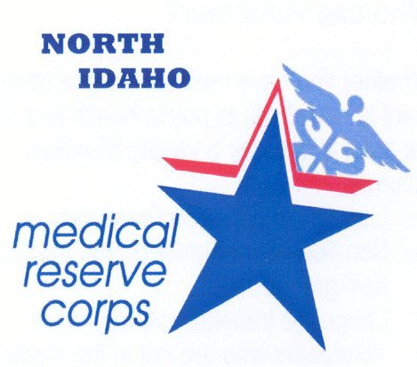
Rock Island County
Medical Reserve Corps
2112 25th Avenue
Rock Island, IL 61201
Telephone: 309-558-2802
Fax: 309-793-4050
Email: nludwig@co.rock-island.il.us

VOLUNTEER APPLICATION

Please print or type
Name

Street Address (Mailing)

City |  |  |  |  | State |  |  |  | Zip
Home Phone | Work Phone |  |  |  |  |  | Cell Phone
Email |  |  |  |  |  |  | Employer
Type: Healthcare Professional:  - Doctor (all categories)  - Nurse  - Pharmacy  - Other ____________ |  | Type: Non Healthcare  - ______________  - ______________  - ______________  - ______________ |  |  |  | Requested means of communication:  - Mail to above address  - Mail to _____________________________  _____________________________  - Email to above
For All Healthcare Professionals: Please indicate License Number or Certificate/Registration Number  Valid Y / N  Expires: ___________ |  |  |  |  |  | Second Language |  |  |  | Third Language
 |  |  |  |  |  | State License Held |  |  |  |  | Degree(s) Obtained
Please list any other specific skills or abilities:

Have you ever been convicted of a felony? Yes No A misdemeanor (other than a traffic violation) Yes No
If yes, please explain:
A Criminal Background Check is required of volunteers:

- I agree to a background check. Birthdate ___/___/___ _ Other Names _________________________________

Do you have any special circumstances or requirements?
Signature |  |  |  |  |  |  |  |  |  | Date

Privacy Act Statement
This information is requested by the Rock Island County Medical Reserve Corps for the purpose of organizing volunteers and staff to respond to area emergencies, disasters or public health emergencies. It will not be utilized or released for any other purpose without your express written permission unless required by law.

Please email to: nludwig@co.rock-island.il.us
Fax: 309-793-4050
Or mail to: Nita Ludwig
2112 25th Avenue
Rock Island, IL 61201
08/31/06

